Раздел 5. Говорение
Imagine that you are preparing a project with your friend. You have found some interesting material for the presentation and you want to read this text to your friend. You have 1.5 minutes to read the text silently, then be ready to read it out aloud. You will not have more than 1.5 minutes to read it.
41
Physical activity is an essential part of people’s development. Exercising as little as 30 minutes a day can greatly improve your health. Exercise makes us strong, fast, patient and disciplined. Regular physical activity is important for our overall health and well-being. Physical exercise strengthens the immune system, improves mental health and helps prevent such diseases as heart and cardiovascular disease, diabetes and obesity.
Regular exercise can help improve your mood, reduce the risk of chronic disease, increase energy levels and even improve sleep. Exercise causes endorphins to be released in the brain. Endorphins are chemicals produced by your body that reduce pain and can make you feel happier.
That is why exercise is the best remedy for depression and stress. Exercise also increases the flow of oxygen to the brain and improves mental clarity and memory.
If your goal is to increase your life span and to have good health, you should lead a healthy lifestyle.
2 Study the advertisement.
Join our Extreme Sports Club!
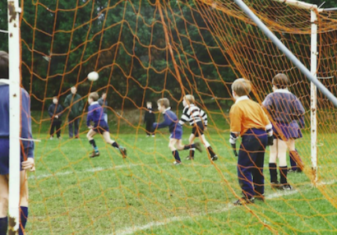
In 1.5 minutes you are to ask five direct questions to find out the following:
- number of training sessions a week
- duration of training sessions
- if special clothes are necessary
- safety measures
- minimum age
You have 20 seconds to ask each questions.
Задание 3
You are going to take part in a telephone survey. You have to answer six questions. Give full answers to the questions.
Remember that you have 40 seconds to answer each question.

Воспользуйтесь плеером, чтобы прослушать запись.
re going to give a talk about foreign languages. You will have to start in 1.5 minutes and will speak for not more than 2 minutes.

Remember to say:
• why lots of people learn foreign languages nowadays;
• why you have chosen to do the English exam this year;
• what you did to prepare for your English exam.
You have to talk continuously.

